

A Project Report

On

**“Reduce the amount of push notifications require for ecommerce apps”**

Batch Details

|  |  |  |
| --- | --- | --- |
| Sl.no | Registration number | Student Name |
| 1 | 20201CCS0003 | Karthik K |
| 2 | 20201CCS0087 | Blesso Samuel Y |
| 3 | 20201CCS0038 | Kushal J |
| 4 | 20201CCS0034 | Dishan G S |

**School of Computer Science,**

**Presidency University, Bengaluru.**

Under the guidance of,

Dr./Ms. Yashaswini K A

School of Computer Science,

Presidency University, Bengaluru

**CONTENTS**

1. Introduction about Project
2. Literature Review
3. Objectives

## Methodology

1. Expected Outcomes
2. Timeline for Execution of Project
3. Conclusion
4. References

**Introduction**

Push Notifications are one of the most important categories in general notifications. They are quite engaging and are used by developers to promote their content, keep their users engaged to the app, reduce app churn-out rates, send out vital app content, access user opinions and data, etc.

**Why should we restrict it?**

1. Excessive push notifications are big turn off for the users, and that could have a major impact on the users interest in the app.
2. Untimely push notifications are distracting and have negative impact for the app and increase the churn rates of the app.

**The domain question here discussed is**

Developer would have to build a solution using Artificial Intelligence or some other mechanism to reduce the amount of push notifications sent by e commerce apps. Currently push notifications are generally sent based on a fixed schedule or some trigger in most apps. This creates multiple notifications every week and irritates the user. The intent should be to only send notifications when the users intent is there to purchase a particular product. Sending push notifications or emails without any user intent to buy that category of product creates frustration to the user. So only when user has intention to buy something the notifications or emails should. The developer has to use a technical method to find that intent using big data and then send notifications or emails according to that method.

**LITERATURE REVIEW**

|  |  |  |  |
| --- | --- | --- | --- |
| Papers | Methods | Advantages | Limitations |
| “Mobile apps in retail: Effect of push notification frequency on app user behavior”, Atilla Wohllebe Dirk-Siegfried Hübner, 28 May 2021 | In total, 17,500 app users are randomly divided into five groups of 3,500 users each. In total, 16 generic non-personalized push notifications are sent, each drawing attention to products. | Provides important information on the concrete effects of too high frequencies.  The research results confirm the necessity of approaches to find appropriate moments to send push notifications to app users. | The app users were chosen randomly but all come from the same app of a retailer. The research results may therefore not be transferred to other retailers or other kinds of apps without further verification. |
| C-3PO: Click-sequence-aware DeeP Neural Network (DNN)-based Pop-uPs RecOmmendation | System Environment  Data Generation  Experiment Result  Deep Learning | The results showed that the system effectively decreased the number of popups and increased the click through rate and 7-day retention rate. | Expected to provide more convenient user scenarios to end users or enterprises.  It lacks to decrease complicated tasks, and to train a high-performed advertisement recommendation system. |
| Automated Extraction of Personal Knowledge from Smartphone Push Notifications Yuanchun Li, Ziyue Yang, Yao Guo, Xiangqun Chen, Yuvraj Agarwal, Jason I. Hong | Dataset Overview  Accuracy of Notification Template Discovering  Accuracy of Template Semantic Analysis  Client Overhead | It is able to automatically identify templates from notification text using pattern mining techniques, and then understand the semantics of the templates through supervised machine learning. | It is not a strong privacy guarantee because the uploaded templates may contain personal information if the templates are incorrect.  This requirement might be hard to fulfill if our system does not have enough users. |

**OBJECTIVES**

* Deciding on the user base of our project to whom we send the notification and the frequency of it
* Analysing user habits on the app for personalized and user- based notifications for enticing user interest
* Collecting data of the user in the application and rating based on the preferred elements by the user on the app
* We need to categorize these app insights and data values and draw out the probability that the user will buy the product
* Based on this, social interactions and association with different products and ads, we can carve out a profile for the user and store it in our system and build our notification strategy

**EXPERIMENTAL DETAILS**

* User interface is based on the market study, intent, specification and prediction deciding a notification.
* As discussed in the domain question the use of AI (Artificial Intelligence) is accepted and any other mechanism is permitted, which can be adapted to our project from various sources.
* The project can be created using platforms which allows to create, design and publish a e-commerce application which is ready with a basic structure and design using AI and ML algorithms embedded in them.
* These advancements can also be used to deploy notifications unto the app using many platforms (AI based, prediction-based) with even having a fixed rate of frequency and specifications of notifications which is open for customization
* So, as mentioned the platforms discussed above for e-commerce app creation and push notification sender and manager are commonly used **Shopify.com** and **omnisend.com** which generates our project’s view.

**METHODOLOGY**

* The Team’s priority in placing the push notifications is to achieve the three qualities that users want

1. Personalization
2. Timeliness
3. Relevance

* We use an AI, prediction-based platform such as Shopify which is a buildable product that includes a core offering across a number of plans. Upon that base layer, we can stack additional products, customize certain components, and add app integrations to create a unique experience that meets each user needs.
* Omnisend is customizable platform to integrate personalized push notifications into your ecommerce application and instantly target your users. The applications can also be connected to many platforms such as shopify.
* Here is a simple example using a image on how a web-push notifications can be set up by omnisend

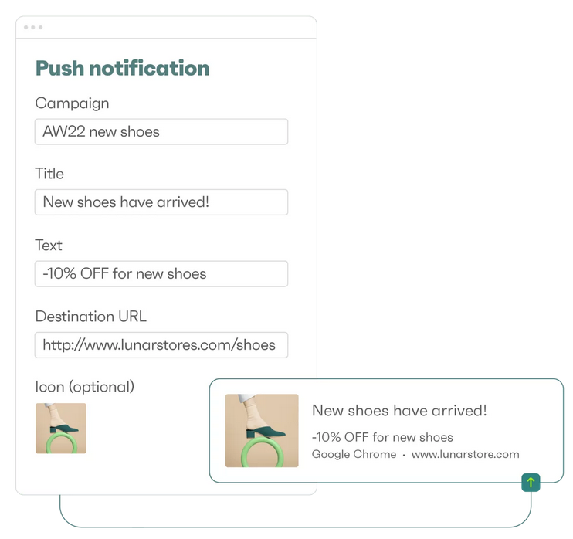

**OUTCOMES**

An E-commerce application is designed included of various categories, cart, product info, price. With well designed app structure and good user-interface

The application is then subjected to web-push notifications which is to display the notifications in context of the e-commerce application

Now the aim is to deliver and enable push notifications based on these perks

* Usability

Users of the app can easily enable or disable them with a simple toggle, and they provide information that is easy to digest.

* Personalization

You can send them messages about products or services that they are interested in also to send special offers or discounts to them.

The web-push notifications are then adjusted and modified for the necessary changes such as the frequency of sending the notifications it may differ based on the notification the managing of it.

The specification including the type the category of notification to be sent is also implemented in the project we alter a specifically designed notification and manage it for our e-commerce application.

**TIMELINE OF THE PROJECT**

As per University guidelines from the document received

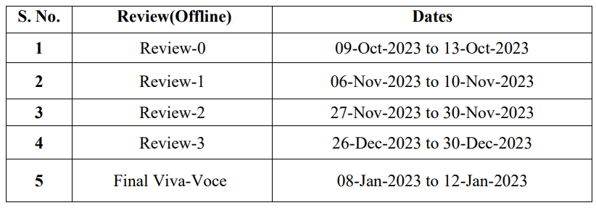

**CONCLUSION**

* Considering this the team leads on to work on a prototype or example of such using a e commerce app and restrict the notification based on user frequent activities, history of category selection and more
* For marketers, the increasing uninstall rate depending on the frequency can be an important basis to calculate the costs of a push notification.
* Push notifications send direct messages to user, widen the e-commerce market’s online reach without straining to capture details through lead forms, and let the users connect with your subscribers easily through a single click opt-in
* It is, perhaps the most successful communication strategy in e-commerce marketing. A lot of that has to do with the high open rate of this sort of message we mentioned above people are as much as 50% more likely to open a push notification message than an email and also because as a direct message it is viewed as being more personal to the consumer.
* It enables the possibility to simplify and streamline lead gathering, customer retention, and many other aspects of building a brand without the need for great expense and complex software.

**REFERENCES**

* Wohllebe, A., Dirrler, P., & Podruzsik, S. (2020). Mobile Apps in Retail: Determinants of Consumer Acceptance – a Systematic Review. International Journal of Interactive Mobile Technologies (IJIM), 14(20), 153-164.
* C-3PO: Click-sequence-aware DeeP Neural Network (DNN)-based Pop-uPs RecOmmendation I Know You’ll Click TonTon Hsien-De Huang† , and Hung-Yu Kao∗ Leopard Mobile Inc.(Cheetah Mobile Taiwan Agency), Taiwan
* Automated Extraction of Personal Knowledge from Smartphone Push Notifications Yuanchun Li, Ziyue Yang, Yao Guo, Xiangqun Chen, Yuvraj Agarwal, Jason I. Hong., 2018
* Breaking barriers to push notification engagement, Leanplum
* Investigating Episodes of Mobile Phone Activity as Indicators of Opportune Moments to Deliver Notifications Joel E. Fischer, Chris Greenhalgh, Steve Benford The Mixed Reality Laboratory University of Nottingham.
* The importance of push notifications in e-commerce alongside consumer and communication by Socital and Socital blogs